M01 Chapter 2 Hands On Projects

HOP 2-3: Calculate the Subnet Mask for a Required Number of IPv4 Subnets
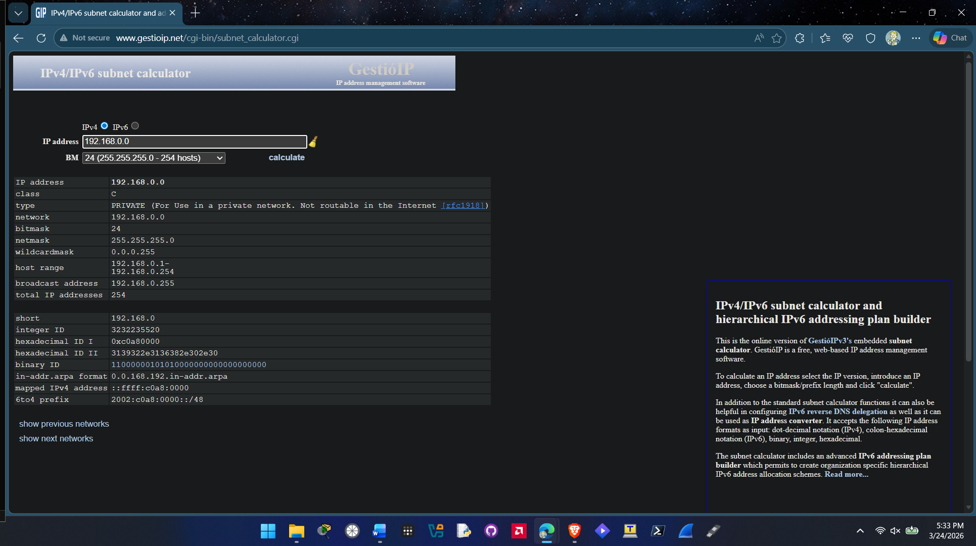

HOP 2-4: Learn IPv4 Subnetting Using an Online Tutorial
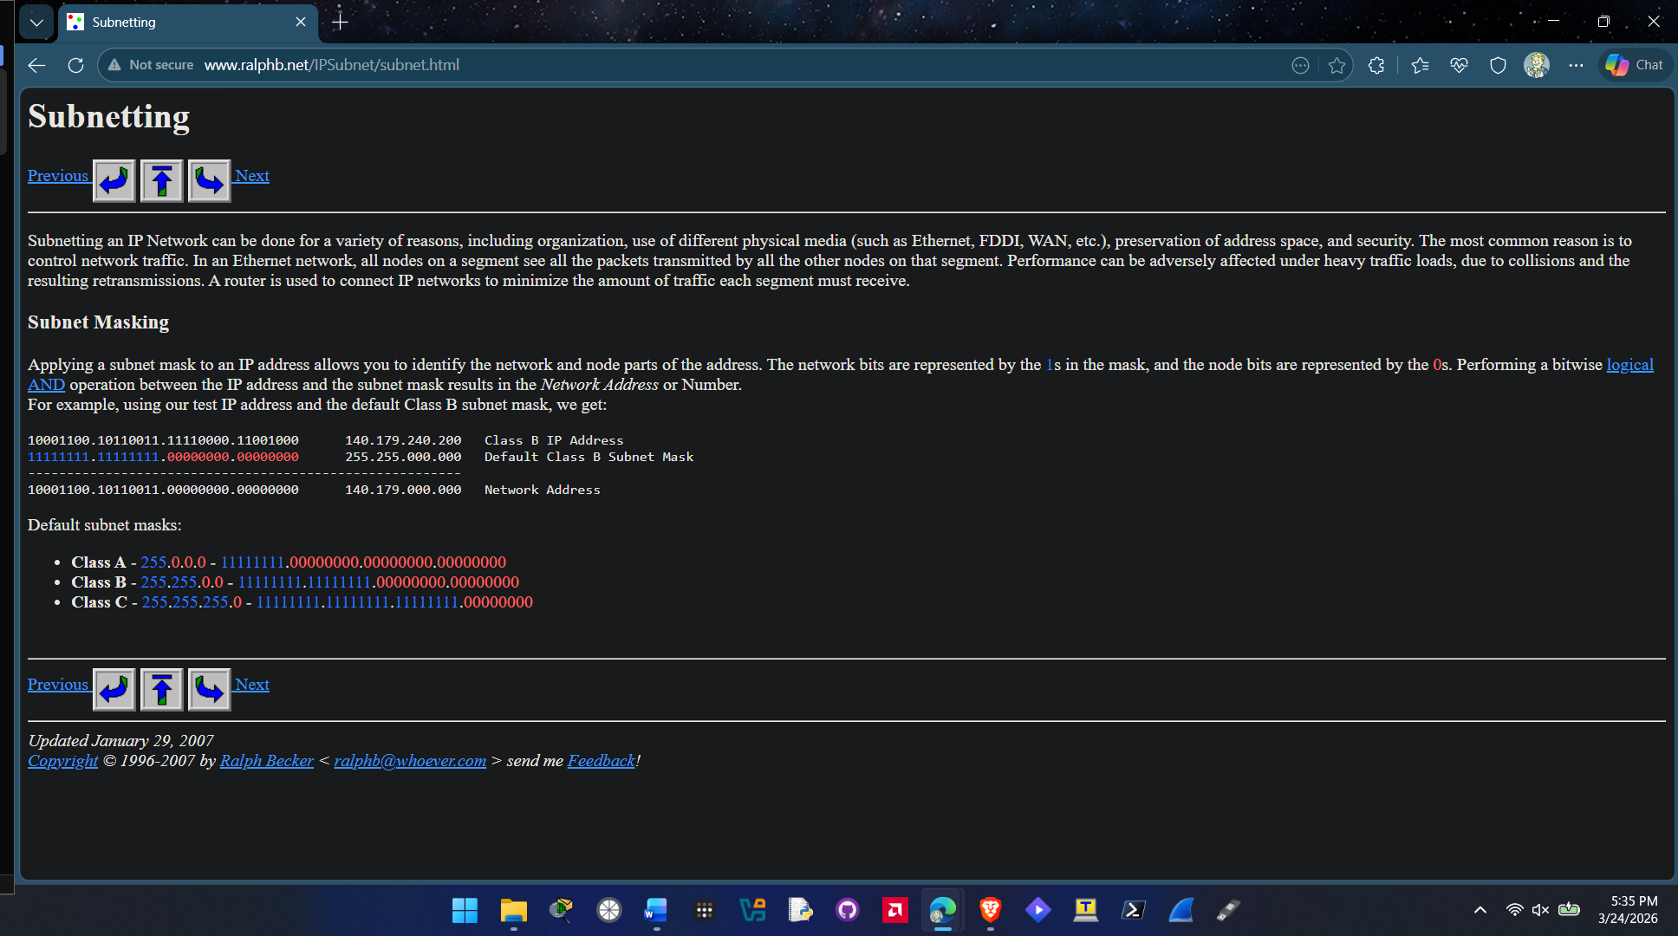
HOP 2-5: Determine the Host Address Range, Broadcast Address, and Other Associated Values for an IP Address Using a Subnet Calculator
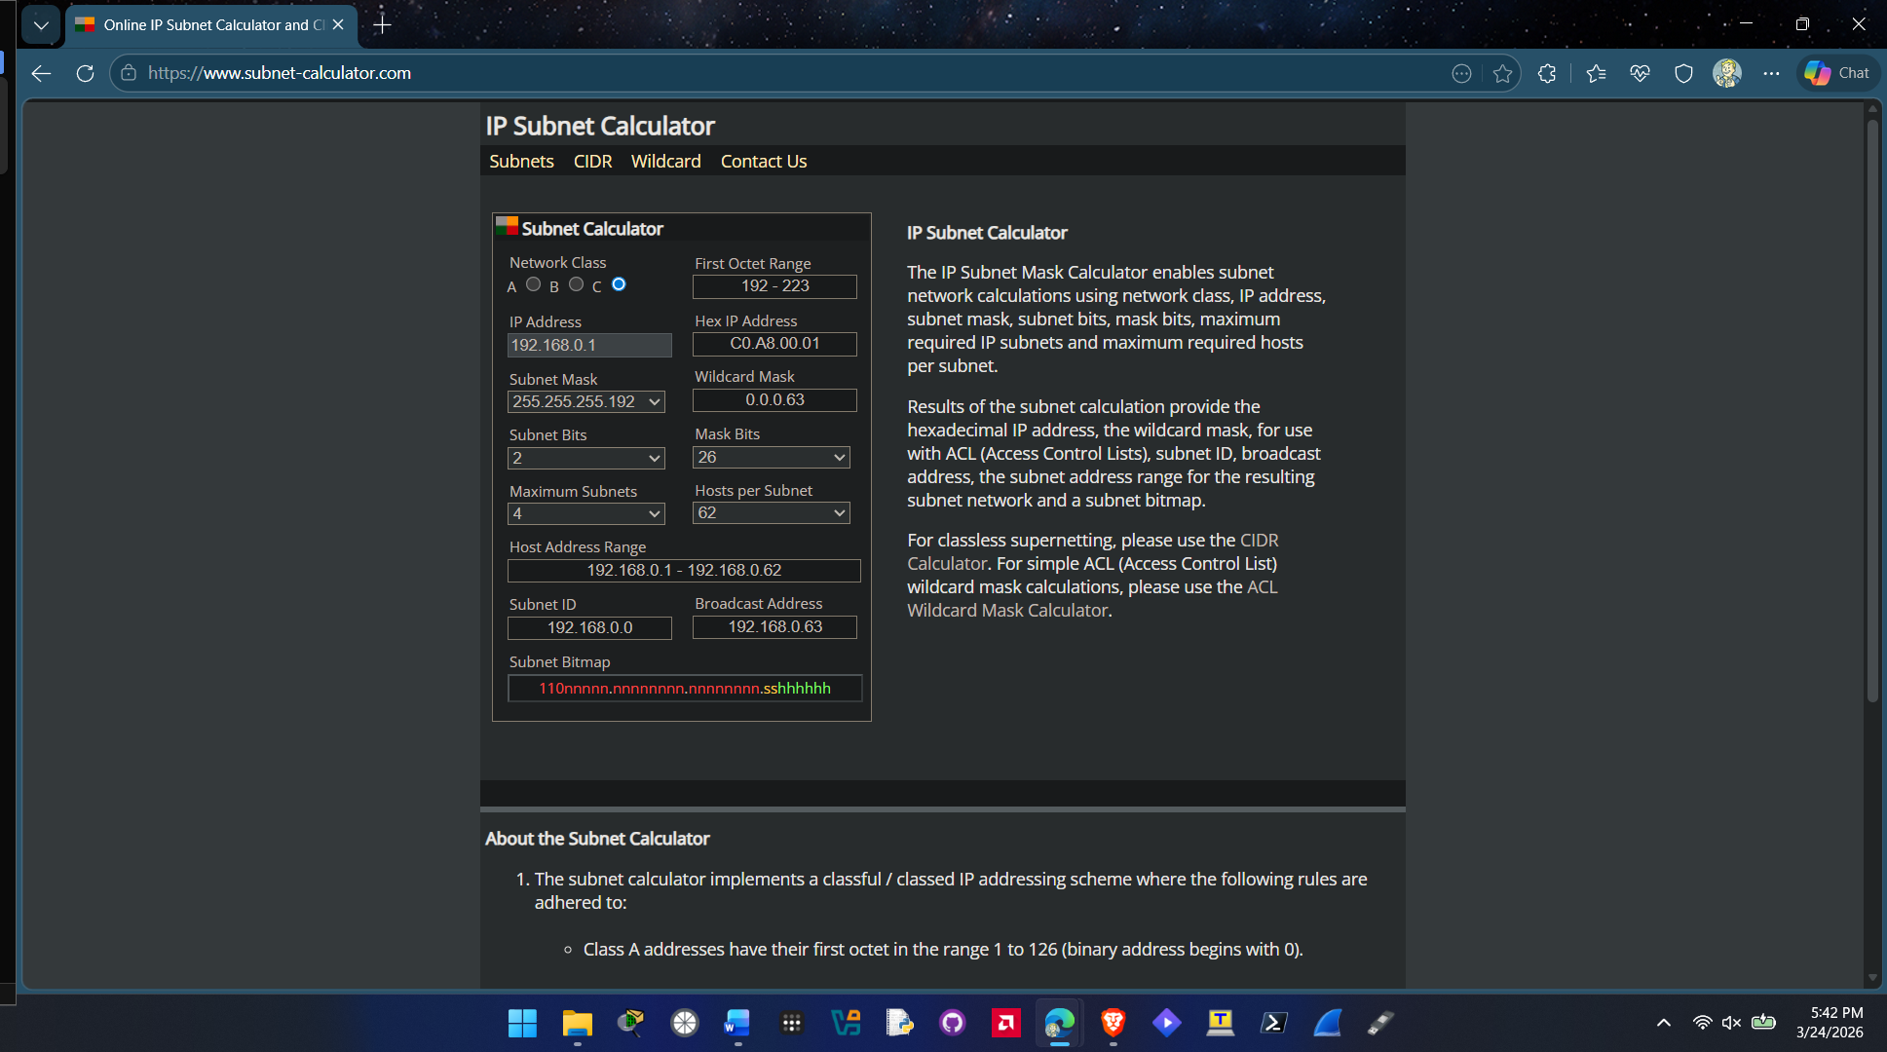
Question 3.
New values after changing maximum Subnets to 4:
Subnet Mask: 255.255.255.192
Subnet Bits: 2
Mask Bits: 26
Hosts Per Subnet: 62
Host Address Range: 192.168.0.1 – 192.168.0.62
Broadcast Adress: 192.168.0.63
Question 6.
New values after changing subnet mask to 255.255.0.0
Subnet Bits: 8
Maximum Subnets: 256
Mask Bits: 16
Hosts Per Subnet: 65534
Host Address Range: 10.0.0.1 – 10.0.255.254
Broadcast Address: 10.0.255.255
Compared to the first set the second set can have a lot more hosts the first one could only have 62 per subnet and the second one can have 65534 hosts per subnet.

HOP 2-6: Review RFCs Related to IPv6 Addressing
RFC 4291
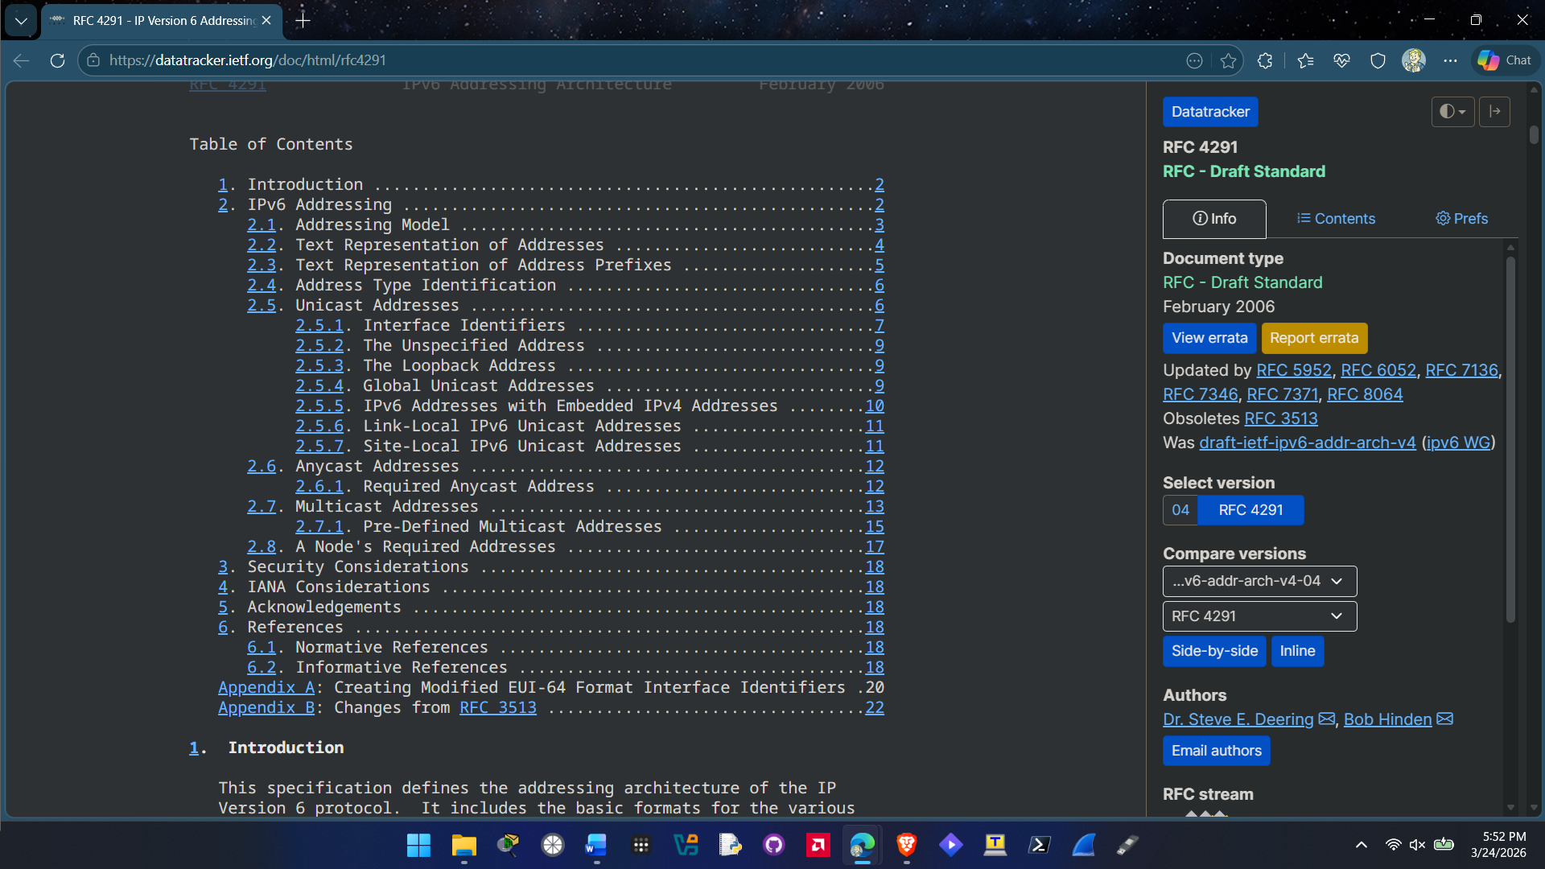

RFC 6052
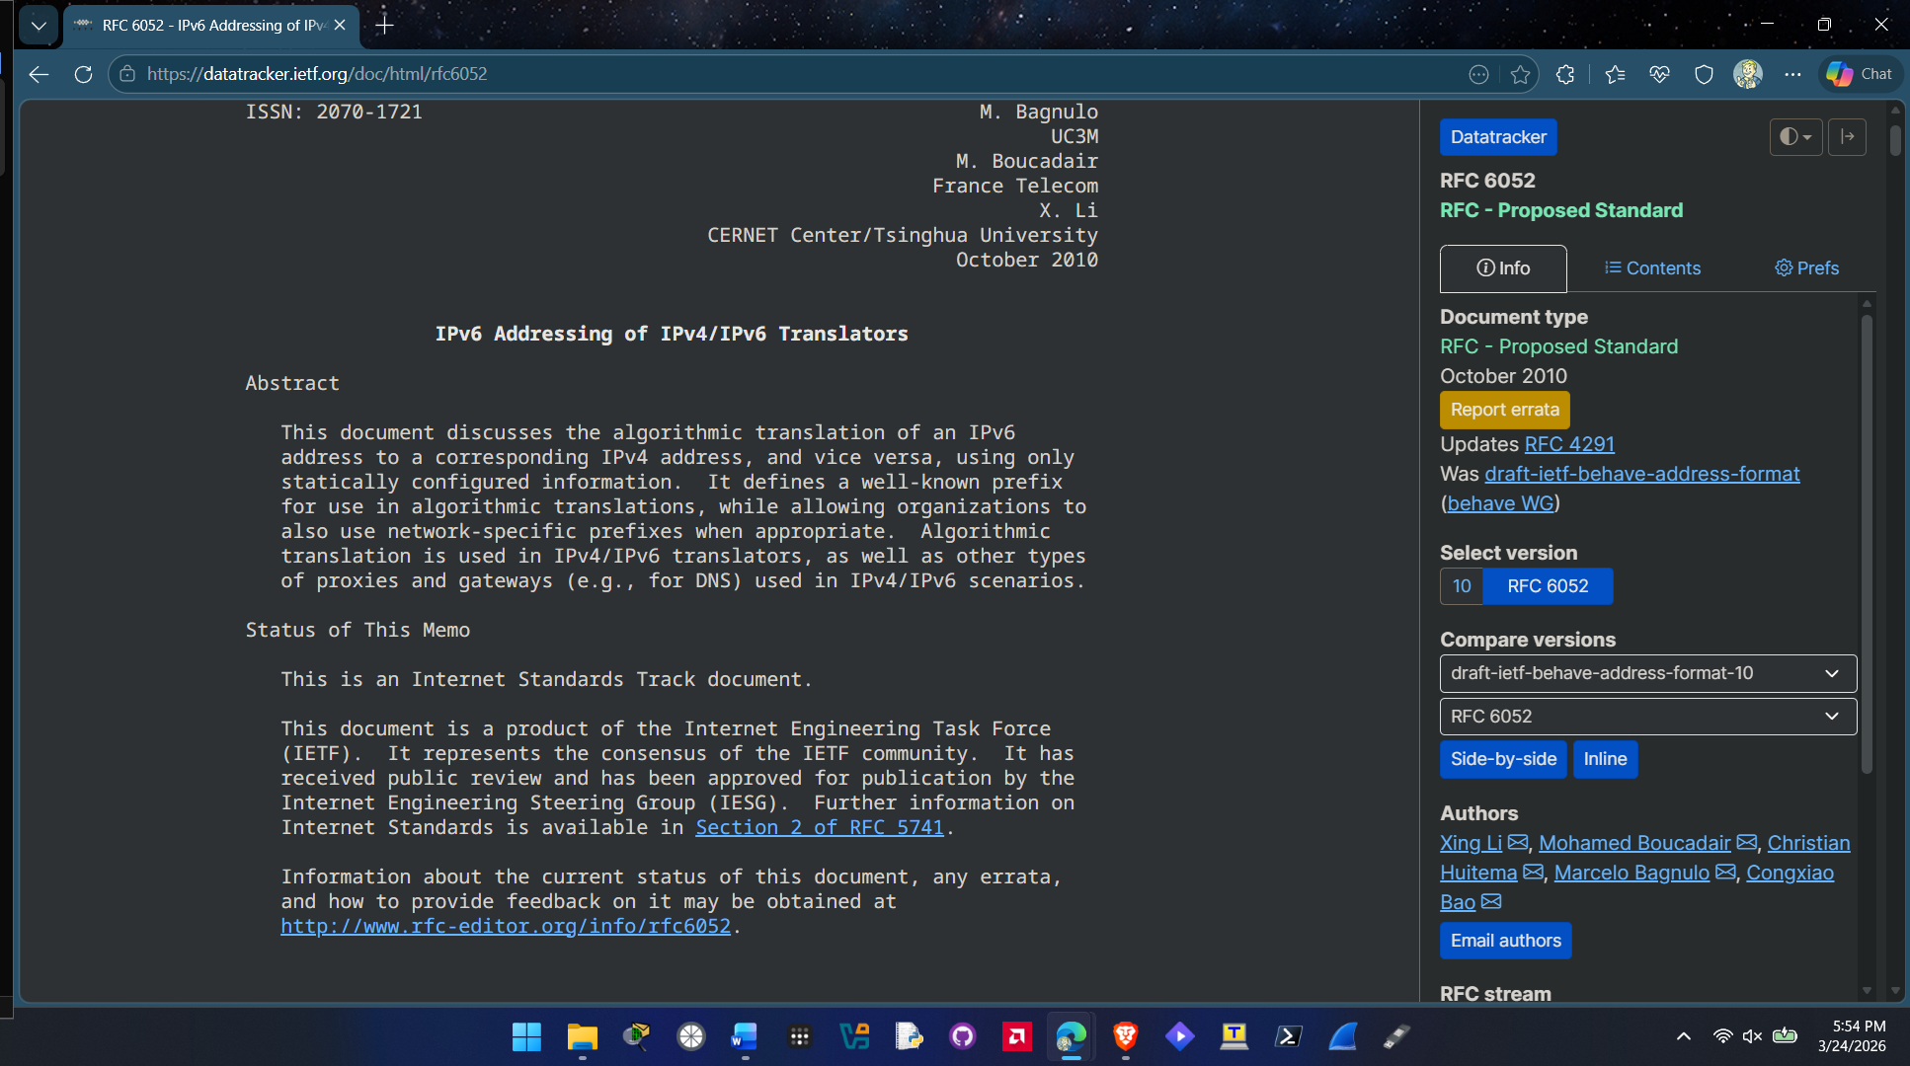

HOP 2-7: Discover the IPv6 Address of a Windows Computer
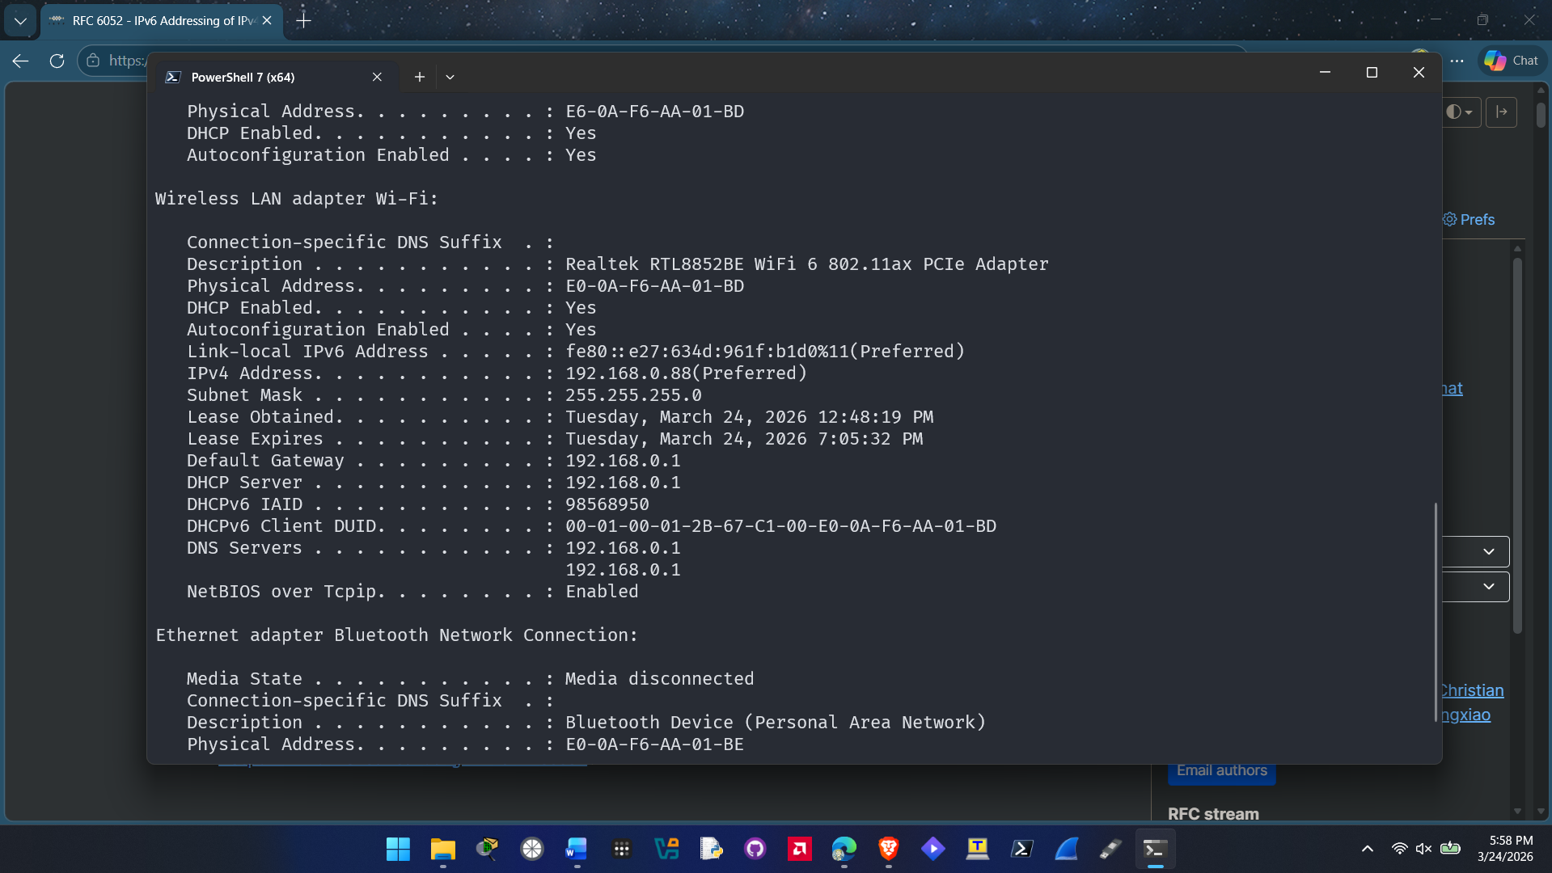
Question 3. Link-Local IPv6 Address: fe80::e27:634d:961f:b1d0%11
Question 6. I can successfully ping ::1 on my device.

HOP 2-10: Access and Work with an ARP Table in Windows
Question 3.
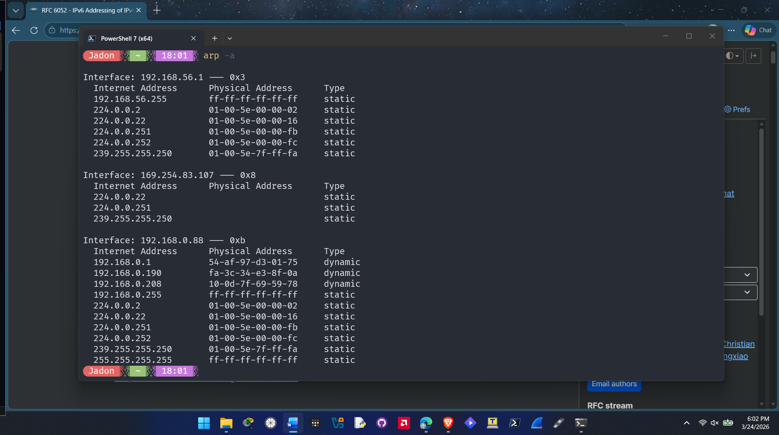
Question 5.
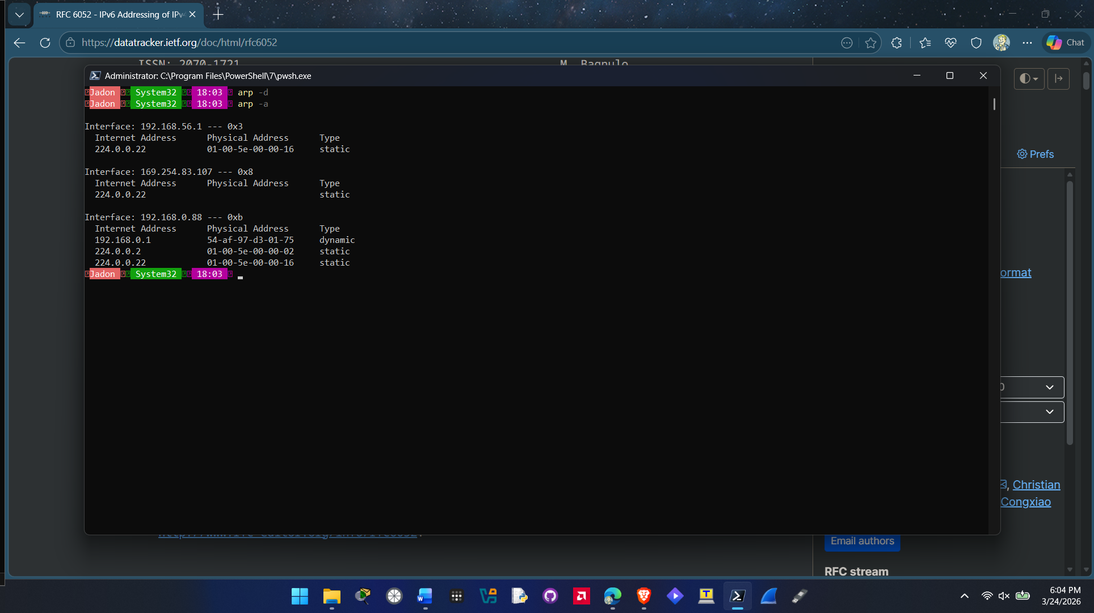
Question 7.
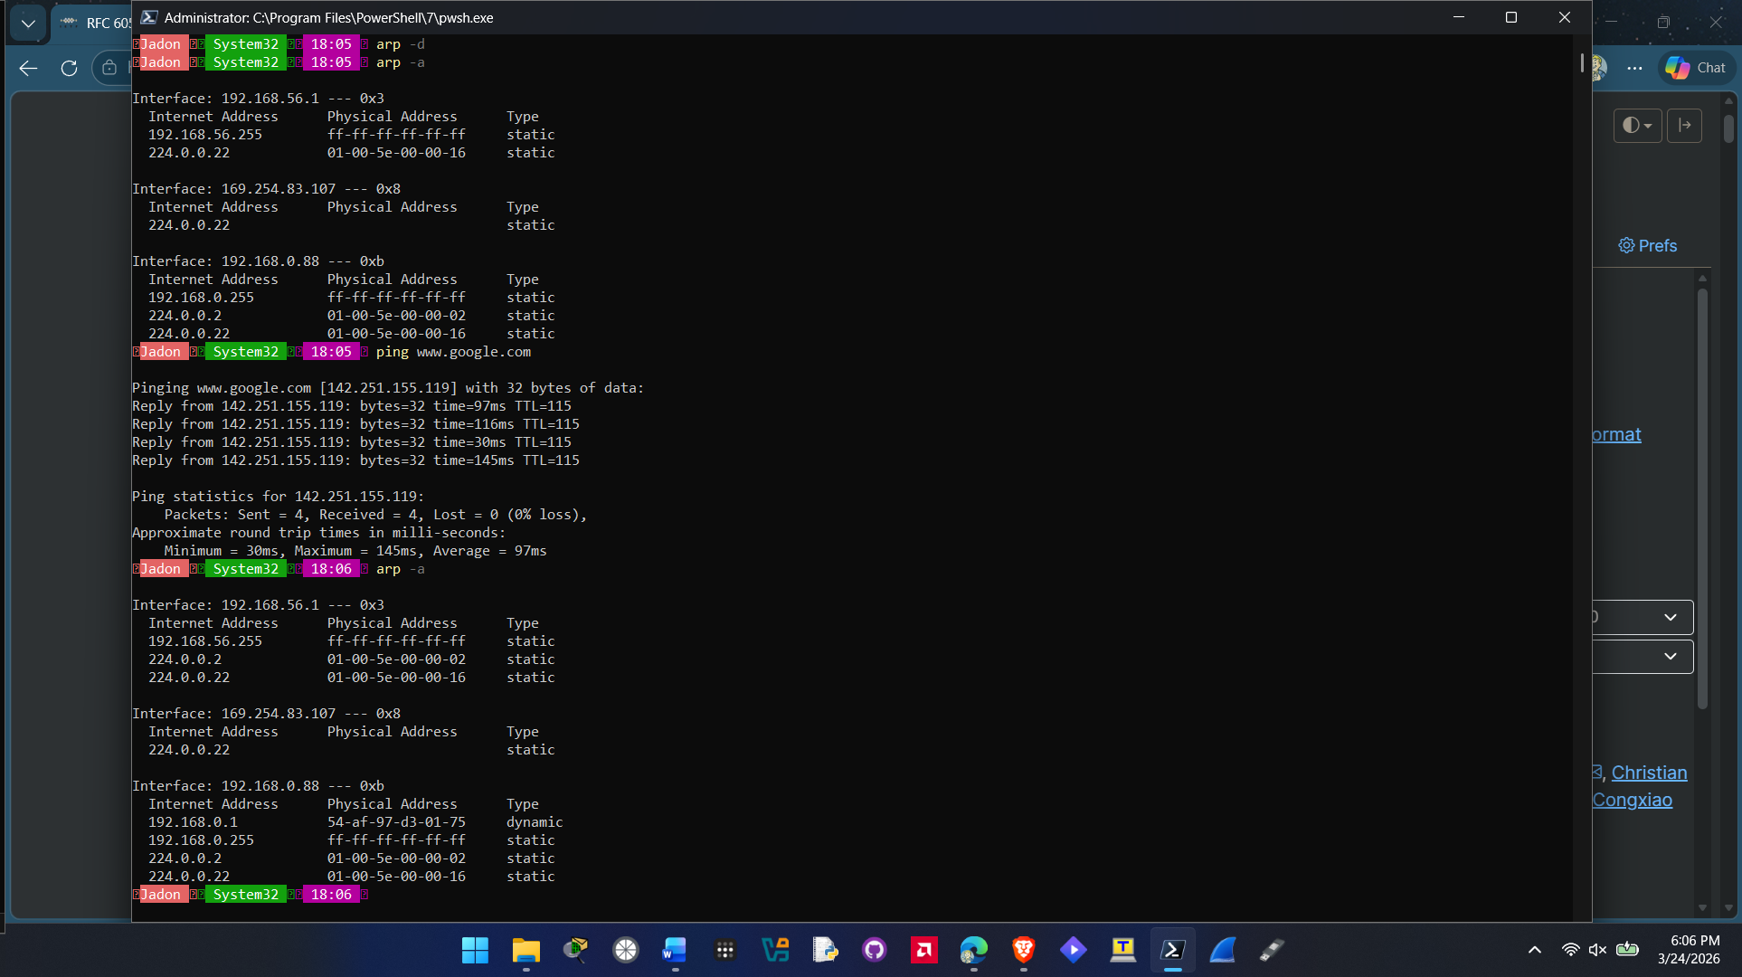
The address added back onto the arp table after pinging google.com was my default gateway 192.168.0.1.

